Use-Case Realization Report
Login

Issue <1.0>
Revision History
Date | Issue | Description | Author
<dd/mmm/yy> | <x.x> | <details> | <name>

Table of Contents
1. Brief Description 4
2. Flow of Events 4
3. Interaction Diagrams 5
3.1 Collaboration Diagram for Login 5
3.2 Sequence Diagram for Login 6
4. Participating Objects 7
5. Class Diagrams 7
5.1 Class Diagram for Login 7
6. Derived Requirements 8

Use-Case Realization Report
Login

Brief Description
this is the use case for login

Flow of Events
[enter the flow of events here; you can use subsections to structure the text]

Interaction Diagrams

Collaboration Diagram for Login
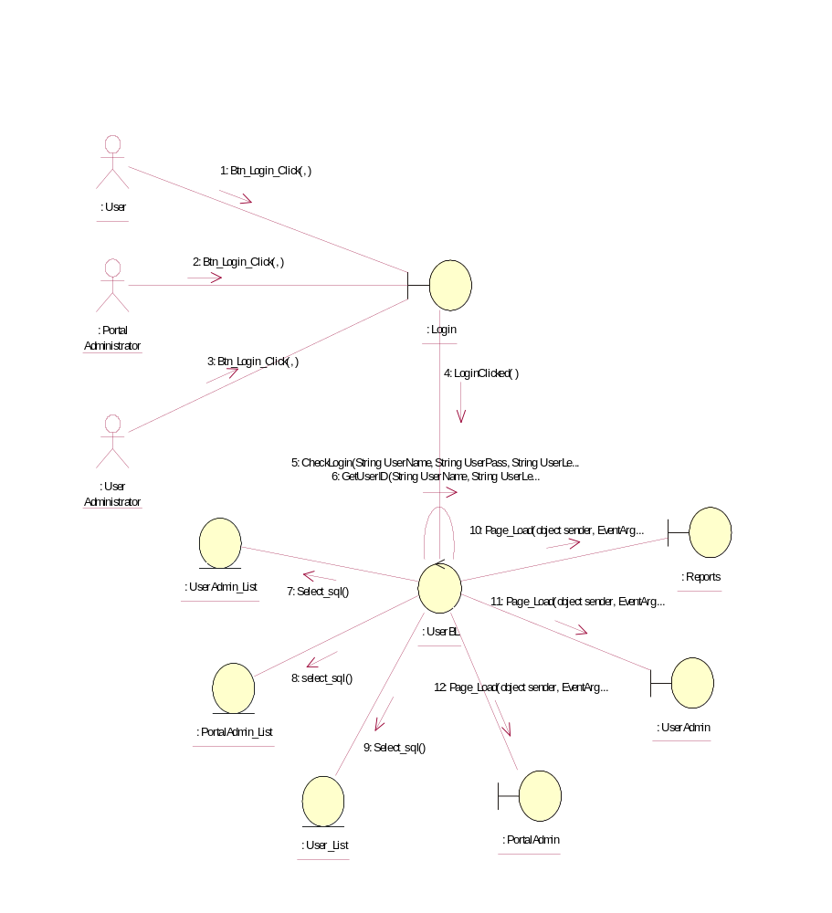

Sequence Diagram for Login
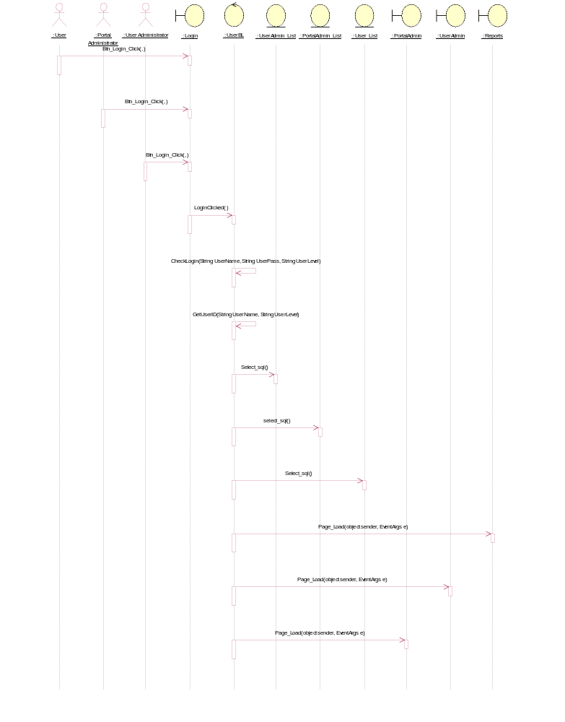

Participating Objects
: Login

: Portal Administrator

: PortalAdmin

: PortalAdmin_List

: Reports

: User

: User Administrator

: User_List

: UserAdmin

: UserAdmin_List

: UserBL

Class Diagrams

Class Diagram for Login
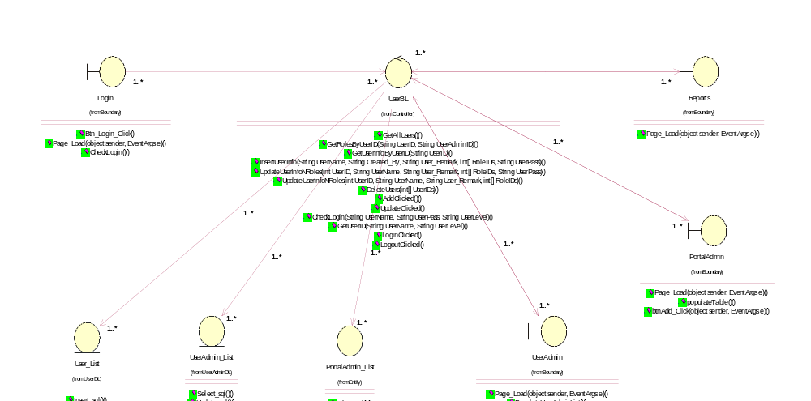

Derived Requirements
[enter the derived requirements here]

